**Inglés 6**

**Quiz evaluativo #1**

ESTUDIANTE: __________________________________ FECHA: __________________

1. Choose the correct answer to complete the sentence with “there is” or “there is”.

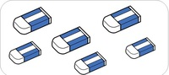 ____________ erases.

* There is not.
* There are
* There is
* There aren´t

 _____________ a computer.

* There are
* There isn´t
* Is there
* There is

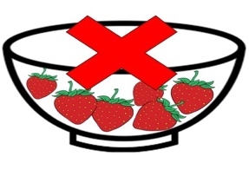 ______________ strawberries.

* There is
* There isn’t
* There aren´t
* There are

 ______________ an old TV.

* There is
* Are there
* There isn´t
* Is there

1. Complete the sentence by writing the correct answer

 ______________ three flags.

 ______________ a school bag.

LOOK

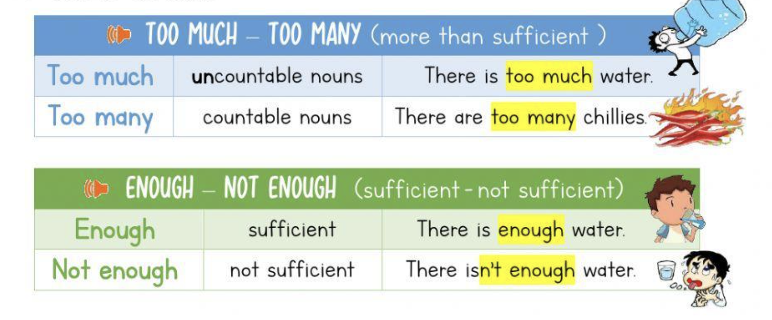

1. According to the previous item, choose:

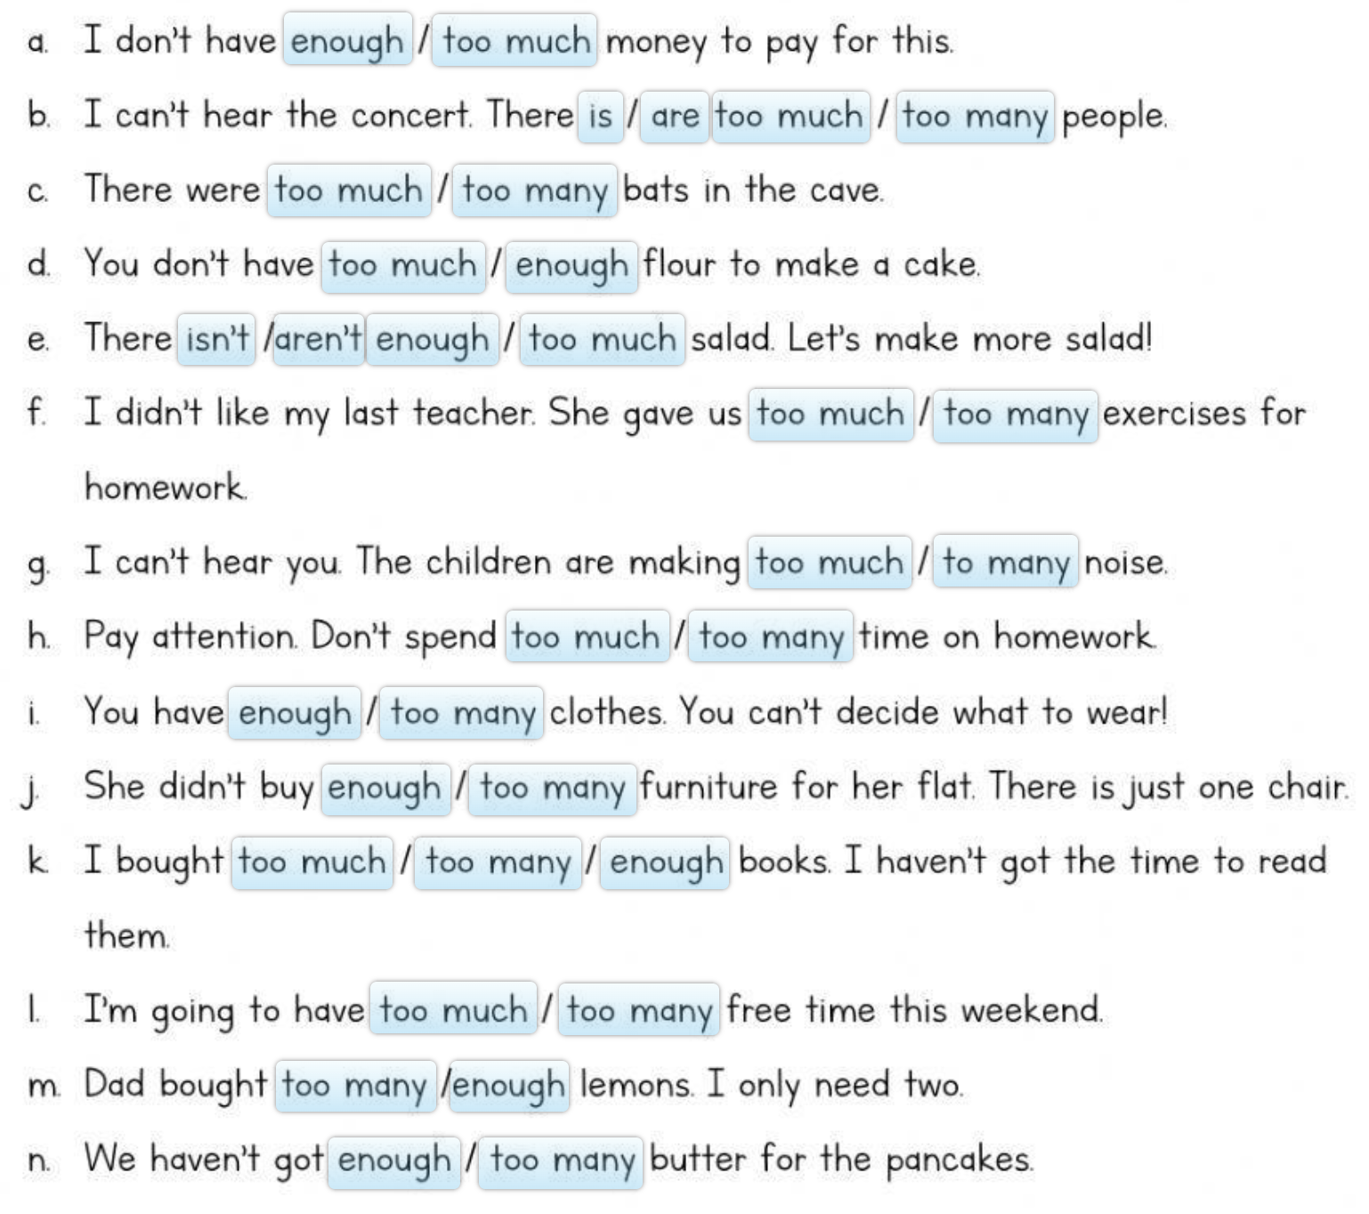

1. Write a 3-paragraph text where you use USED TO and WAS / WERE appropriately.
2. Write the following sentences in the past tense:
3. I am not a teacher.
4. They are having a party.
5. We are delighted to see him.
6. He is still sleeping.
7. She is a bit scared.
8. You are not on the list.
9. This/that is not a cat.
10. You are all at school.
11. Complete these sentences with WAS/WERE in the past simple:

* We ______________ in Canberra last spring.
* Jamie ______________ 25 last June.
* You ______________ very busy on Friday.
* I ______________ at home yesterday.
* ______________ you at work this morning?
* He ______________ not surprised by the present.
* It ______________ not very dangerous.
* She ______________ interested in science.

1. Fill in the blanks in the following sentences using USED TO. They can be affirmative, negative or interrogative phrases:

* I _____________________ walk to school every morning.
* ______ you __________________ go on holidays to the beach?
* I ______________________ like garlic in my food, but I love it now.
* We ____________________ eat lots of sugar, but we’re on a diet now.
* She ____________________ come to our parties, but she’s started coming recently.
* _______ he _________________ drink so much? I can’t remember seeing him like that before.
* I __________________ believe in ghosts, but then I went to a haunted castle and I saw things I can’t explain.
* She ____________________ come to our parties, but she’s started coming recently.

1. Complete the following exercise:

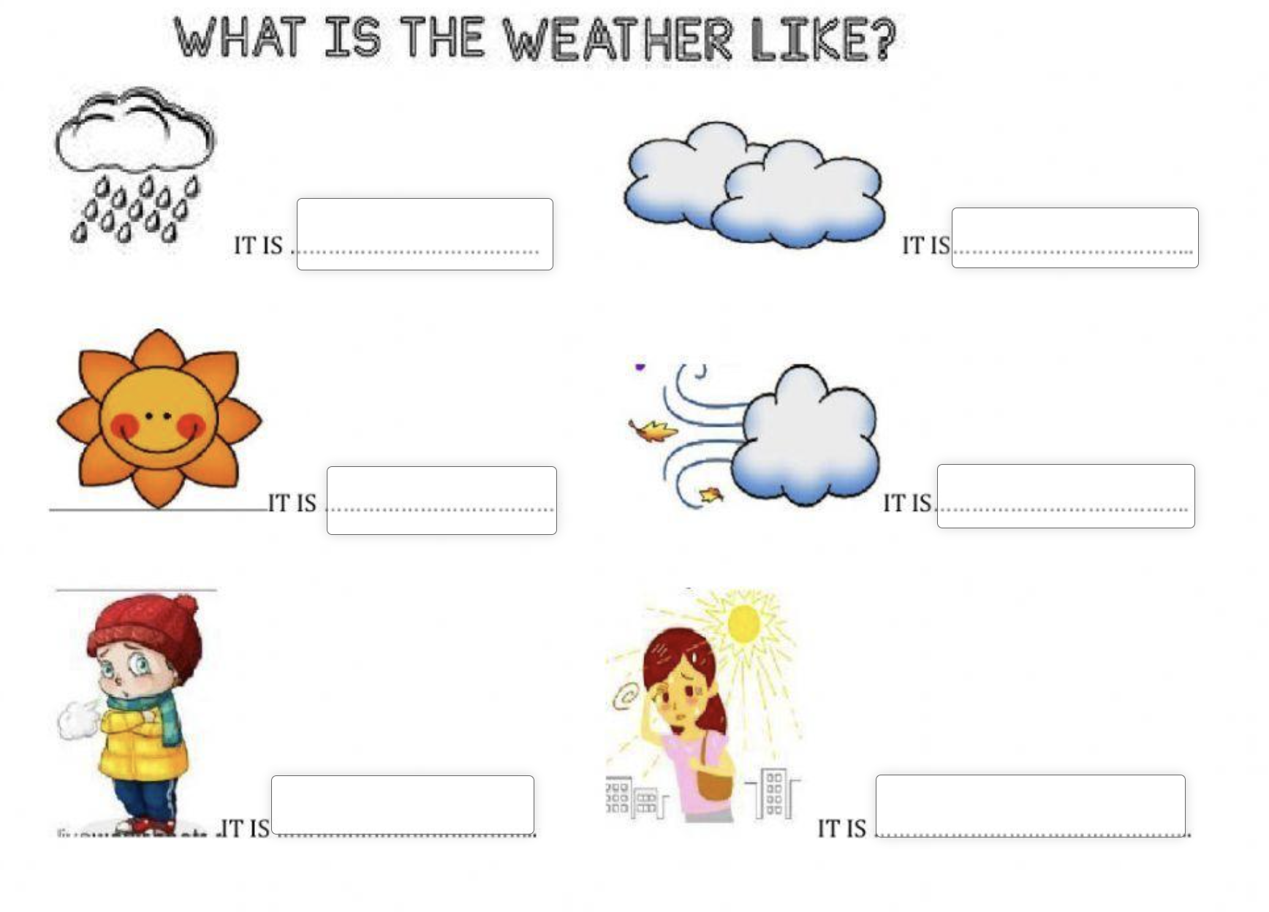

9) Look at the images and complete the crossword puzzle:

